The 10 Best out of 70: Qualifying Round for the FWQ*** on Kitzsteinhorn Mountain
Jubilant winners at the Open Qualifier for the X OVER RIDE Big Mountain Contest in Zell am See-Kaprun
In bright sunshine and perfect conditions, the last entries for the X OVER RIDE, which will take place this coming Saturday, March 24th as a three-star qualifier for the renowned Freeride World Tour (FWT), were awarded last Saturday, March 17th. During the Open Qualifier event, 70 riders on skis and snowboards battled it out for the last wild cards for the X OVER RIDE, which can bring important points towards the Freeride World Tour ranking. The passionate freeriders had to bring their A game for this: The course ran from Geißstein (2,230m), along some very steep hills with plenty of rocks as natural jump ramps for spectacular tricks, to the finish area near Salzburger Hütte (1,860m). In the end, the winners were announced: Three male skiers and three male snowboarders, as well as two female skiers and one female snowboarder received the coveted starting positions for the X OVER RIDE. For visitors and fans, a spectator area on Langwiedboden, right beside the finish area offered a great view of the entire race track. From there, they will also be able to watch the freeride action during the main event this coming Saturday right up close. All information about the X OVER RIDE can be found at: www.x-over.at.
Kaprun, March 20th, 2012.The first place among the male skiers went to Zeno Cecon from Italy, followed by two Austrians. In the men’s snowboarding discipline, all three tickets went to Austrian riders, with Franki Wörndl in the lead. Among the ladies, skier Ann Buhl Bersang (DNK) and snowboarder Amber Schuecker from Australia beat out the competition. With this, the starting line-up for the X OVER RIDE is now finalized: 75 riders from a total of 16 nations will start in the race on Saturday, March 24th. Out of 360 registrants, the 65 best skiers and snowboarders were selected based on their current FWT qualifier ranking; the remaining 10 spots were awarded through the Open Qualifier last Saturday. It therefore doesn’t come as a surprise that there will be as many as 16 different nations starting in the three-star qualifier for the world’s most renowned freeride tour. The international starting line-up also includes some Austrian riders: Fabian Lentsch, the 18-year-old rookie from Tyrol, already earned big points with commanding performances in his first FWT season. At the start among the ladies is skier Nadine Wallner (AUT), currently in third place in the FWQ ranking. The current leading lady in the FWQ ranking is snowboarder Manuela Mandel (AUT) who will also try to expand her lead at the X OVER RIDE.The best Austrian male snowboarder in the starting line-up is Alexander Hoffmann. He currently holds fourth place in the FWQ ranking.
700 Metres in Altitude Difference – Numerous Jumps – Only a Few Minutes
The main event will take place on the Lackerschneid hill (2,652 m). Within only a few minutes, the riders will master an altitude difference of 700 metres on their skis and snowboards, including many technical passages and spectacular jumps. The finish line is at Langwiedboden at 1,970 metres above sea level.

Perfect View for Spectators
Those who want to catch a whiff of freeride air can do so directly from the spectator area on Langwiedboden in the immediate vicinity of the top station of “Gletscherjet 1”. The competition area has been designed so spectators will have a perfect view of the spectacular runs from there. And for young snowboarders and skiers under 19, Kitzsteinhorn Mountain offers a special bonus: “The Power of ZEHN”.Every Saturday, young riders can buy their ski passes for only 10 Euros – including during the main event of the X OVER RIDE.

Safety Comes First
Even if the freeride hills outside the regular slopes are often spectacular and inviting, safety always comes first in freeriding. Not only do the riders prepare themselves extremely well for the run to be conquered during the so-called “face checks”; they are also well-trained in avalanche awareness and search strategies. As part of the X OVER RIDE, all visitors can gain hands-on experience for the case of an emergency by practicing the handling of the latest avalanche victim search devices in the supervised PIEPS avalanche search field.

Riders Party at Baumbar
After a spectacular and adrenaline-filled day on the mountain, participants and spectators can “relax” at the Riders Party at Baumbar Kaprun. With free admission, the “rulers of the hills” will be duly celebrated and rewarded for their efforts and their boldness.

The Freeride World Qualifier Tour
The Freeride World Tour is the most important freeride tour worldwide. With a total of only 16 male skiers and 9 male snowboarders as well as 8 female skiers and 5 female snowboarders, the starting line-up is limited to the world’s best riders. Qualification can be achieved through the Freeride World Qualifier Tour, where every year the three best skiers and the two best snowboarders in the ranking are chosen for the extremely elite starting line-up of the FWT. The FWQ Tour events are categorized in events from one to four stars. The higher the category, the more points can be won towards the ranking.

The detailed results of the Open Qualifier are available at: http://www.x-over.at/pages/de/about-the-event/results-open-qualifier.php

X-OVER RIDE Kitzsteinhorn 2012: The Schedule

23.03.2012 – FWQ ***
all day Face Check
16:00 – 18:00 Accreditation at Race Office
18:00 Riders Meeting

24.03.2012 – FWQ ***
07:15 – 08:00 Riders Face Check
08:00 – 08:15 Riders Meeting, Judges Info
09:00 – 13:30 Start at Geißstein - 75 Riders
14:00 Victory ceremony
20:00 Riders Party at Baumbar Kaprun

High-Resolution Images
are available at http://www.x-over.at/pages/de/press.php for free download.

Press Contact
Sabrina Maier | identum communications
T +43 1 480 22 72-11|M: +43 699 1770 1899
maier@identum.at
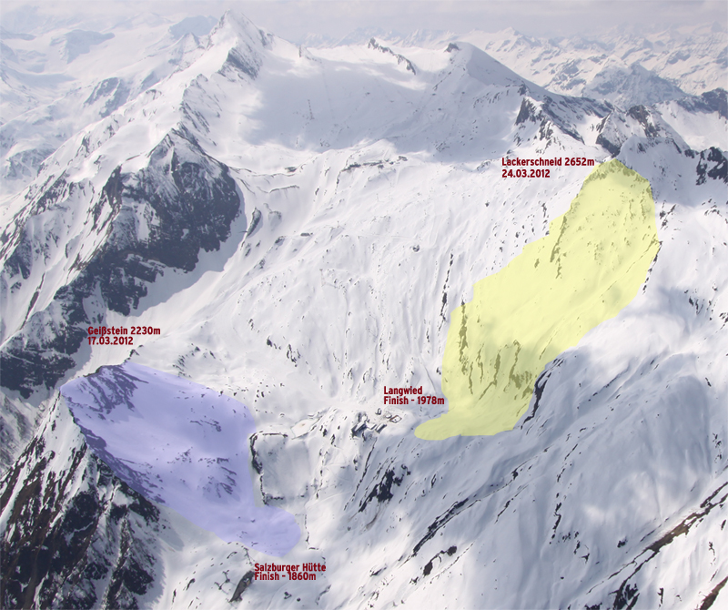
24.03.2012 – FWQ *** Main Event
- Start: Lackerschneid 2,652m
- Finish: Langwied, Häuslalm 1,970m
- 75 Starters;10 from Open, 65 from ranking

17.03.2012 - Open Qualifier
- Start: Geißstein 2,230m
- Finish: Salzburger Hütte 1,860m
- 70 Starters

