Freeriders from 26 Nations Starting at the X OVER RIDE on Kitzsteinhorn Mountain
On March 24th, Zell am See-Kaprun will be firmly in the hands of the international freeride scene.
Kitzsteinhorn Mountain is calling – and the freeriders are coming. 320 riders have registered for the X OVER RIDE, which will be held as a three-star qualifier for the Freeride World Tour (FWT) this year for the first time. The Big Mountain Contest on Saturday, March 24th, is limited to 60 riders; this means that of the 320 registrants, only the top 52 riders will be starting in this event according to the current Freeride World Qualifier (FWQ) seeding list. Registrants come from as many as 26 different nations – this guarantees an international atmosphere in the skiing region of Zell am See-Kaprun. The Open Qualifier on March 17th offers a second chance for all those who did not make it into the starting line-up due to their FWT qualifier points thus far. In this event, the last eight tickets for the main competition on Saturday will be awarded. The X OVER RIDE offers optimal conditions, not only for the freeriders but also for all those who want to watch the spectacular runs from up close. Both runs are perfectly visible from the Langwiedboden area, right beside the top station of the “Gletscherjet 1” gondola. All information regarding the X OVER RIDE can be found at www.x-over.at.
Kaprun, March 8th, 2012. The main event will take place on the Lackerschneid hill (2,652 m). Within only a few minutes, the riders will master an altitude difference of 700 metres on their skis and snowboards, including many technical passages and spectacular jumps. The finish line is at Langwiedboden at 1,970 metres above sea level. The run for the Open Qualifier goes along the opposite hill, from Geißstein (2,230 m) to Salzburger Hütte at 1,860 metres. During last week’s safety check, organizers found both hills to have a well-solidified basis and stable and safe conditions.

Strong Austrians at the Start
The international starting line-up also includes some local riders: Fabian Lentsch, the 18-year-old rookie from Tyrol, still rode with the Juniors last year, and thanks to strong performances in his first FWQ season he already advanced to number nine in the current ranking. Starting among the ladies is the skier Lorraine Huber (AUT). She is already participating in the Freeride World Tour this year, and was able to land second place at the most recent FWT event in Røldal. The best Austrian snowboarder in the starting line-up is Alexander Hoffmann. He currently holds third place in the FWQ ranking. The current leader in the FWQ ranking, skier Mathieu Bijasson (FRA), will also start in the X OVER RIDE and try to extend his lead with additional points.

Second Chance during the Open Qualifier: The Best 8 of 80.
With 150 registrations for the maximum of 80 starting positions, the Open Qualifier is also popular with the riders who are looking to win important extra points for the Freeride Qualifier Ranking. The last eight tickets for the main competition will be awarded to three male skiers and two male snowboarders, two female skiers and one female snowboarder.

Perfect View for Spectators
Those who want to catch a whiff of freeride air can do so during the qualifier event as well as the main event, directly from the spectator area on Langwiedboden in the immediate vicinity of the top station of “Gletscherjet 1”. Both competitions have been designed so spectators will have a perfect view of the spectacular runs from there. And for young snowboarders and skiers under 19, Kitzsteinhorn Mountain offers a special bonus: “The Power of ZEHN”. Every Saturday, young riders can buy their ski passes for only 10 Euros – including during the main event of the X OVER RIDE.

Riders Party at Baumbar
After a spectacular and adrenaline-filled day on the mountain, participants and spectators can “relax” at the Riders Party at Baumbar Kaprun. With free admission, the “rulers of the hills” will be duly celebrated and rewarded for their efforts and their boldness.

The Freeride World Qualifier Tour
The Freeride World Tour is the most important freeride tour worldwide. With a total of only 16 male skiers and 9 male snowboarders as well as 8 female skiers and 5 female snowboarders, the starting line-up is limited to the world’s best riders. Qualification can be achieved through the Freeride World Qualifier Tour, where every year the three best skiers and the two best snowboarders in the ranking are chosen for the extremely elite starting line-up of the FWT. The FWQ Tour events are categorized in events from one to four stars. The higher the category, the more points can be won towards the ranking.

X-OVER RIDE Kitzsteinhorn 2012: The Schedule
17.03.2012 - Open Qualifier
07:00 Check-in at Gletscherjet valley station and uploading to Gletscherjet 1 top station
07:15 – 08:00 Riders face check
08:00 – 08:15 Riders meeting, judges info
09:00 – 13:30 Start at Geißstein - approx. 80 riders.
14:00 Victory ceremony

23.03.2012 – FWQ ***
all day Face check
16:00 – 18:00 Accreditation at race office
18:00 Riders meeting

24.03.2012 – FWQ ***
07:15 – 08:00 Riders face check
08:00 – 08:15 Riders meeting, judges info
09:00 – 13:30 Start at Geißstein - approx. 80 riders.
14:00 Victory ceremony
20:00 Riders Party at Baumbar Kaprun

High-Resolution Images
are available at http://www.x-over.at/pages/de/press.php for free download.

Press Contact
Sabrina Maier | identum communications
T +43 1 480 22 72-11|M: +43 699 1770 1899
maier@identum.at
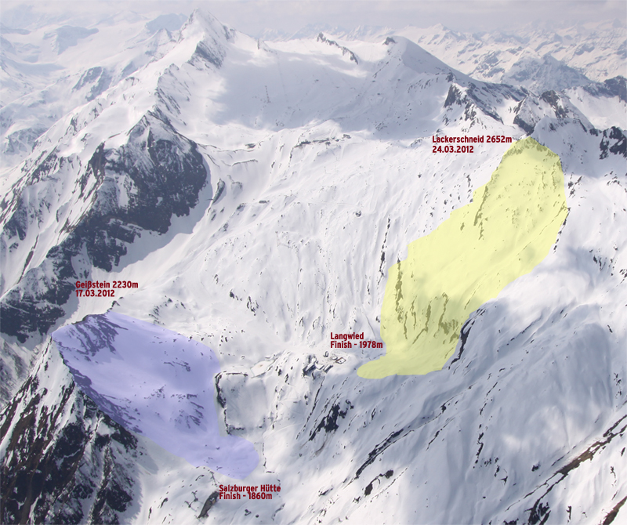
24.03.2012 – FWQ *** Main Event
- Start: Lackerschneid 2,652 m
- Finish: Langwied, Häuslalm 1,970 m
- 60 Starters - 8 from Open, 52 from ranking

17.03.2012 - Open Qualifier
- Start: Geißstein 2,230 m
- Finish: Salzburger Hütte 1,860 m
- 80 Starters

